LIFE MEMBER NEWS
Spring 2017
From the President: Bryant “Bubba” Blankenship Hello Life Members, It has been a pleasure serving as your President. As our year comes to an end, I would like to thank everyone on the board for all that you have done this year to make the LMA better. I will cherish this year.
From what I hear I will be leaving the reigns in some very capable hands who has a complete board in place pending elections.
Here's to a wonderful end and a great start to a new year. With love and regards
Bubba
--------------------------------------------------------------------------------------------------------------------------------------------------------
Membership Vice President: Lin Martin Hello Life Members!
HAPPY SPRING!! It's hard to believe that this year is almost over with! Time really is flying by faster and faster!! I want to thank everyone for their support this year. It has been a great year!! Thank you to everyone who paid their membership dues this year. Don't forget to pay Sharon Showalter, Treasurer, at the meeting in May for your 2017 - 2018 dues. Paying your dues helps us continue to do our great suites at meetings, which at one time or another, we have all enjoyed the great food and drink there and other programs.
Put it on your calendar if you haven't already and be sure to invite any Life Members that you know to the LMA/Senate meeting in May. The Senate will be hosting this meeting and we're looking forward to a great time! Once more information is available about the location, we will be sure to put it out to everyone, I hope see as many people as possible at the Wine Tour and Banquet in Pulaski April 8th. I have put in a very special request for beautiful weather for that weekend (so hopefully no snow, just beautiful blue skies). The wineries are really looking forward to having our group visiting them. I'm really looking forward to seeing everyone that will be able to make it that weekend, and if you can't make it, you will be missed. If we don't see you then, I hope to see as many people as possible in Richmond. Lin

Management Vice President: Lee Wolfe
Happy Spring everyone! I truly do believe it's finally upon us for good. I love this time of year, and love where I live - one can just watch Spring growing through the mountains! That also means motorcycle season; yea!!! So, as you travel throughout your daily routine, or anywhere for that matter, watch out for the motorcycles!

Anyhow, a couple reminders: first, we do have the camp fundraiser going on through Leandra Finder's Amway campaign: go to www.amway.com/dreamcatcher and see what all is offered on the site. A portion of your purchase goes to CVJC. She also can provide us a list from Dr. Shirley of products CVJC can use from the site, so you can purchase, have sent to Camp directly, and they will get a portion of the goods, all at one time! Second, please everyone, remember what the LMA represents for the state organization, and all the different ways we can help. Their membership may be down, but they are definitely not out yet! Please reach out to your local chapters or those in surrounding areas, and see what can be done to help them out and GROW! I also want to take this opportunity to once again congratulate our two new members Grant Hummer and Michael Raymer; hope to see you both at our meetings and become active in our happy family.
And, I look forward to all the new members that I know Patrick is currently scaring up, and the new liaison also, whomever they may be! See you soon!
Lee Wolfe

Communications Vice President: Melissa H. Sleeth
Happy Spring to the Life Member Association! As we come into April and the Spring time, we look to our final meeting of this year in May and think about next year already. Thanks so much to all of you for attending our meetings and events, and contributing to the way we communicate! It's been a lot of fun working with President Bubba this year, as well as my fellow elected and appointed Board members. I specifically want to thank Joyce Cooke, our newsletter editor, for working hard and putting this great newsletter together each quarter; to Rob Cooke, for keeping us up to date on the website; and to Jennifer Rebby, our communications guru, for managing our information on the List Serve and on Facebook. I look forward to seeing many of you at our May meeting, and thanks again for serving the LMA in each and every way that you can!
In Jaycees, Melissa H. Sleeth

LIAISON-Patrick Knightly
Hey Virginia Jaycee Life Members! Guess what? I got to stand behind a podium and say things about people at the VA Jaycees Year-End Meeting in Newport News in February. It was nice catching up with people and welcoming our two newest Life Members: Grant Hummer and Michael Raymer from Virginia Beach.
BUT the fun doesn’t stop there because we will be welcoming another new Life member during the banquet following our Wine Tour in Southwest Virginia in April. I hope you can join us in the celebration.
Of course, three new members is a good start, but we want to end this fiscal year in May with more Life Members. As I said in previous newsletters other chapters or individuals have indicated a desire to present their chapters’ outstanding members with Life Memberships, and others are holding back. I could use help especially in the NOVA region, and certain chapter(s) in the Capital Region. Our year ends in May, and we can still get some more new Life members in before then. Your help is appreciated…
Please encourage your chapters to nominate worthy participants or give a hint to a Jaycee that can help a chapter complete a nomination.
The application form is on the LMA website and linked to the Virginia Jaycees website. Please feel free to contact me with any questions at pjknightly@yahoo.com or by phone/text at 804-687-3868. I'll be happy to guide anyone through the application process and read any nomination drafts if desired. Let's recognize those Jaycees who deserve a Life Membership!
Patrick
Hospitality Director-Roz Goin
Happy Spring Everyone,
Here's hoping all of your snow has melted and the flowers are bursting with color. Okay, enough gushy stuff. The May meeting will be here before you know it. Along with your LMA shirt and nametag, I INSIST that you pack your appetite. I expect each and every one of you to eat often and largely!! Saturday lunch will be chicken salad croissants, orange congealed salad, pasta salad and a selection of desserts. Don't forget that the price of lunch has increased.
I'll see you soon,
Momma Roz
Chairman of the Board-Sam Goin
Hello Life Members,
This is the time of year for elections. At the May meeting we will be electing a President, 3 Vice-Presidents and a Secretary. We will need Directors that will be appointed. Please consider being an officer or a Director for the LMA next year. We have some fine people that have already stepped forward to run.
President-Mike Wolfe
Vice-President: Membership-Patrick Knightly
Communication-Christina Brunne
Management-Lee Wolfe
Secretary-Joyce Cooke
Look forward to seeing you at the May meeting.
Past President Sam

Chaplain-Mike Wolfe
Hello fellow Life Members,
I have been told for many years that there are no stupid questions, only stupid answers. There is no shame in answering a question with the response of, "I don't know." So why do some people have an answer for everything? I personally have an opinion on this matter. If you know nothing about the question being asked, say "I don't know," or better yet, just keep it to yourself! Giving someone false information can cause more damage than good.

I am a very opinionated person. If I know something worth passing on, I do so! I am not, however, a Know-It-All. You all know who I'm talking about. Dealing with these people can be tricky. Those of you that have a religious background have probably heard the saying, "Well, bless their heart!" That's a loving way of calling them an idiot!

I truly believe that you should love everyone, and should not judge anyone. A little trick that my pastor has taught me through the years is "Love God, love your neighbor; that doesn't mean you have to take them fishin'"! Wise words to live by, don't you think??

Mike Wolfe

TREASURER’S REPORT-SHARON SHOWALTER
Hi Everyone,
As of March 31, we have collected dues from 79 people for the current fiscal year, and 4 people have paid ahead for the next fiscal year 2017-2018 which starts June 1 (thank you!). The list of paid members includes:
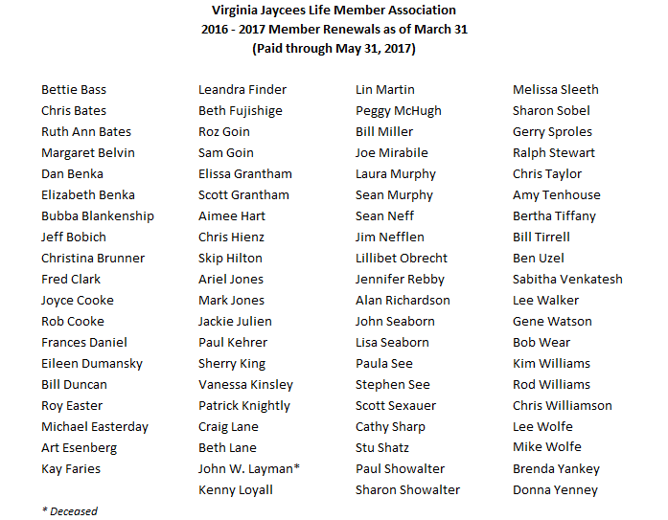
Only paid members will be able to vote in the election at the May meeting.
As a reminder, everyone is up for renewal again starting June 1. Please bring your renewal checks to the May meeting or mail them to me using the renewal form included in this newsletter.
The proposed budget for the current fiscal year was approved at the February meeting. This is the first LMA budget passed in several years, and will serve as a template for future budgets. The approved budget covers income and expenses through May. The incoming board will be responsible for proposing a budget for the next fiscal year.
Sharon Showalter
LMA Treasurer 2016-17 sharonshowalter@comcast.net

Virginia Jaycees Life Member Association Dues 2017-2018
Dear Fellow Life Member,
The Virginia Jaycees Life Member Association is continuing its efforts to reconnect with all Life Members. If you know of any member who has lost contact with us, please let us know.
The Life Member Association dues year is June 1, 2017 to May 31, 2018. You can choose to pay one of two types of dues:
Regular Dues ($30 per year) – Member may vote, run for office, conduct the association’s business and receive all issues of the newsletter. Member may also enjoy the hospitality suite at State Meetings.
Sustaining Dues ($40 per year) – Member is entitled to all the benefits of regular membership. The additional $10 goes into the general fund and provides the Association with an additional source of income to cover expenses.
Membership Dues (circle one)
Regular $30 Sustaining $40
Checks are payable to: Virginia Jaycees Life Member Association
PLEASE PROVIDE US WITH YOUR CONTACT INFORMATION

Name

Address

City State Zip

Home Phone Work Phone

Mobile Phone Spouse Name

Email Address

LMA # Chapter
Mail completed form and dues payment to:
Sharon Showalter, Treasurer
818 North Danville Street
Arlington, Virginia 22201
703-812-8131
sharonshowalter@comcast.net
Thank you for renewing your membership!
SECRETARY’S REPORT-JENNIFER REBBY
Virginia Jaycees Life Member Association
General Membership Meeting
Marriott at City Center, Newport News, VA
February 18, 2017 @ 10:30am
Call to Order by President Bubba at 10:32am
Pledge of Allegiance led by President Bubba
Invocation given by Chaplain, Mike Wolfe
Secretary – Jennifer Rebby
November meeting minutes distributed, Art Eisenberg motion to approve, Jay Bates 2nd. All in favor.
Treasurer – Sharon Showalter
- LMA currently has 72 members.
- Members asked to pay dues, forms distributed.

Products – Lee Wolfe
Multiples items available, including business cards. Forms available. Please request products by email at Lee@elevenwest.com.
Management Vice President – Lee Wolfe
- Camp Fundraiser. Leandra Finder reports Amway fundraiser still in progress. We can purchase items and designate camp so that a portion of proceeds from the sale of Amway products go directly to Camp Virginia Jaycee, monthly, through December 2017. Specific website to order from is http://www.amway.com/dreamcatchers. Leandra will has catalogs available.
- Sherry King reports Anne Johnson can do a Pampered Chef fundraiser and donate her commission.

State Function Vice President – Melissa Sleeth (on behalf of Joyce Cooke)
Hospitality: LMA Suite is open. Lunch @ 12:00, $5 fee for lunch

Virginia Jaycees 2017 State President Kristin Miller introduced herself, addressed those present. Her theme this year is “Inspire the Future.”
Membership Vice President - Lin Martin
- Flyers available for Spring wine tour in Pulaski, 4/7-4/8. Golf tee time is also available. Event will include a banquet dinner and the presentation of new Pulaski Life Memberships. Lee Wolfe requests we let her know today if members may attend Spring Wine Tour.
- Working with chapters to suggest new Life Memberships.
- Please pay dues.
- 50/50 Raffle fundraiser took place.

Communications Vice President – Melissa Sleeth
- Thanked Joyce Cooke for newsletter. Next deadline for newsletter articles is 3/31/17.
- Thanked Jennifer Rebby for posting news on Facebook, List serve.
- Requested that a link for the camp fundraiser be added to the LMA website.

Liaison – Patrick Knight
- Two new life memberships will be presented at banquet in Pulaski.
- May will be another opportunity to present new life memberships.
- Requests help encouraging Fredericksburg chapter to nominate past president for a life membership.

COB remarks – Sam Goin
- Need to know those members who want to serve on the LMA Board next year. No volunteers yet.
- Read list of officers needed for the Board.

Old Business
- Beertopia: Bubba Blankenship (on behalf of Sean Neff) advised members to see email from Sean for details. Event date changed, Roanoke chapter needs help.
- Proposed Budget Discussion:
  - Suggestions from Budget Committee: Need to increase income: increase suite lunch fee from $5 to $10, need more new Life Members, need more fundraisers.
  - Jackie Julien inquired and advised proposed operating budget is for fiscal year only
  - Beth Fujishige inquired about cost of suites. Stu Shatz inquired about profit from lunch fees; LMA actually loses money over conference weekend. Stu Shatz also inquired if savings account can be used to pay for camperships.
  - Upon discussion, Beth Fujishige motion to move proposed budget discussion to Bylaws Committee to add campership in memory of Robert Hager to Bylaws. Steve See 2nd. Motion approved.
- Beth Fujishige motion to include current cost of memberships as a line item in proposed budget. Steve See 2nd. Beth Fujishige accepted Friendly Amendment that cost of camperships come from savings account
- Call the question from Jay Bates. Approved with 1 Nay from Paul Showalter.
- Sherry King clarified that money in savings account historically used to pay for camperships and provide financial assistance. Former multiple accounts were combined to create single, current savings account.
- Paul Showalter expressed need for a budget for future boards, who will want to know financial needs to plan fundraising.
- Sherry King inquired about Budget Committee discussion regarding fundraising and decreasing expenses. Sam Goin responded increased hotel room rates has increased LMA expenses.
- Sabitha Venkatesh suggested mailing campaign to inactive Life Members, inviting them to become active again, to increase membership and amount of dues received. LMA does not send dues invoices. Sam Goin noted current lack of opportunity to add new Life Members now that Virginia Jaycees only has two state conferences a year. Chris Taylor suggested Treasurer could send out a specific dues invoice on the List serve. Sherry King requested a list of inactive Life Members from the Treasurer so the past LMA presidents can call them to encourage renewals.

New Business
- President Bubba stated he is taking orders for an LMA display ornament, a light-up “Old Farty”, $25 each, as a fundraiser.
- Result of 50/50 Raffle was $74 won by Ruth Ann Bates. Melissa Sleeth paid $20 for a polo shirt, Sherry King paid $10 for a t-shirt and Paula See paid $5 for a t-shirt. Total of $109 earned at meeting.
- Stu Shatz polled members for interest in a LMA cruise this year, organized by Ron Sleeth.
- Jackie Julien reports LMA/Senate outing will be 5/19-5/21. Researching hotel quotes in Richmond.

Presidential Remarks
President Bubba glad to see members. It has been a fun year.
Adjournment – meeting adjourned at 11:36 am.

Jaycee creed - led by Gerry Sprole
Addendum
- Paul Showalter stated no actual vote on proposed budget occurred during meeting.
- First meeting reconvened at 11:45 am for the purpose of voting on proposed budget for fiscal year 2016-2017.
- Paul Showalter motion to approve proposed budget for fiscal year 2016-2017. Leandra 2nd.
Motion approved with 1 Nay vote.
A BIG THANK YOU TO OUR BOARD FOR THEIR WORK THIS YEAR!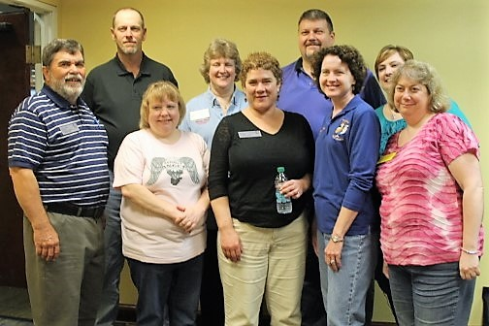
EDITOR-JOYCE COOKE
Hope you’ve enjoyed the newsletter this year! It’s been my pleasure to help our LMA family! Have a great summer! Joyce

