LMA CRUISE June 5 -12,2022
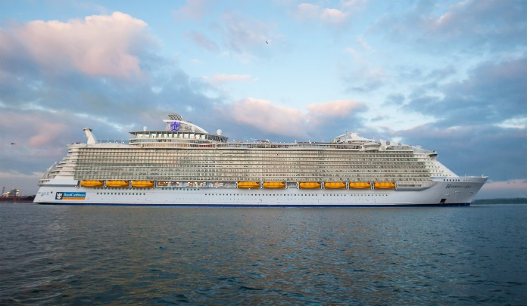
ROYAL CARIBBEAN HARMONY OF THE SEAS
Grab your toothbrush and sun screen--we're going on a cruise!!
*June 5-June12, 2022
*Royal Caribbean Harmony of the Seas out of Port Canaveral, Florida.
Itinerary:
- Port Canaveral
- Coco Cay
- Cruising Day
- St. Thomas
- St. Maarten
- 2 Cruising Days
- Port Canaveral
At the current time we have a group rate for 5 interior cabins and 5 balcony cabins. There is a NON-REFUNDABLE deposit of $50/cabin. The interior cabin is $1,071.13/per person (port fees and taxes included). The balcony cabin is $1,576.13 (port fees and taxes included). If you want to make sure you get the cabin you prefer, you need to contact our very own TRAVEL GUY, Ron Sleeth. His phone number is 804-281-7100 ext. 4461972 and his email is rsleeth@aaamidatlantic.com. If you have a Crown and Anchor number, please make sure to give it to Ron.
Important reminders: The group is absolutely guaranteed for 30 days only. You must have a passport good for 6 months after your return.
If you have any questions, please contact me 434-315-3001 or rbgoin@yahoo.com.
I think I'll start packing tomorrow ⛴️😎
Roz Goin

